Trunk-Based Development

What is Trunk-Based Development?
# Source: AI Source: Provided by: [Data Path: Persons Table -> ID Column: 1, Name_En Column: Motasem Essam] -> From: [ChatGPT] on [2/15/2026]
Trunk-Based Development (TBD) is a software development workflow where all developers integrate their work frequently into a single main line of development (often called “trunk” or “main”).
The main branch always stays up-to-date and deployable, and long-lived branches are avoided.
TBD focuses on small, incremental changes and encourages continuous integration of code to reduce conflicts and maintain stability.

How It Works
# Source: AI Source: Provided by: [Data Path: Persons Table -> ID Column: 1, Name_En Column: Motasem Essam] -> From: [ChatGPT] on [2/15/2026]
- Developers work on short-lived branches or directly on the main trunk.
- Code changes are integrated frequently (often multiple times per day).
- Automated testing or verification ensures changes do not break the main line.
- Incomplete features can be hidden using feature flags or configuration toggles.

Conceptual Visualization
# Source: AI Source: Provided by: [Data Path: Persons Table -> ID Column: 1, Name_En Column: Motasem Essam] -> From: [ChatGPT] on [2/15/2026]
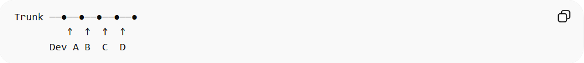
Trunk ──●──●──●──●──●
↑ ↑ ↑ ↑
Dev A B C D
All developers commit small changes to the trunk regularly, keeping it stable.

When It Is Used
# Source: AI Source: Provided by: [Data Path: Persons Table -> ID Column: 1, Name_En Column: Motasem Essam] -> From: [ChatGPT] on [2/15/2026]
- Teams practicing continuous integration and continuous delivery
- Projects that release frequently or continuously
- Agile development teams
- Large and small teams needing fast integration and collaboration

Advantages
# Source: AI Source: Provided by: [Data Path: Persons Table -> ID Column: 1, Name_En Column: Motasem Essam] -> From: [ChatGPT] on [2/15/2026]
- Reduces merge conflicts
- Keeps main trunk always deployable
- Encourages small, incremental changes
- Works well with automated testing and CI/CD pipelines

Disadvantages
# Source: AI Source: Provided by: [Data Path: Persons Table -> ID Column: 1, Name_En Column: Motasem Essam] -> From: [ChatGPT] on [2/15/2026]
- Requires discipline and frequent integration
- May require feature flags for incomplete work
- Risky if automated tests or verification are not robust
- Can be challenging for very large teams without good CI processes

Key Idea (General Summary)
# Source: AI Source: Provided by: [Data Path: Persons Table -> ID Column: 1, Name_En Column: Motasem Essam] -> From: [ChatGPT] on [2/15/2026]
Trunk-Based Development = Developers integrate small, frequent changes into a single main line → main trunk is always stable and deployable.
It’s a general workflow concept in software development that supports continuous integration, collaboration, and fast delivery, not tied to any specific version control system.

